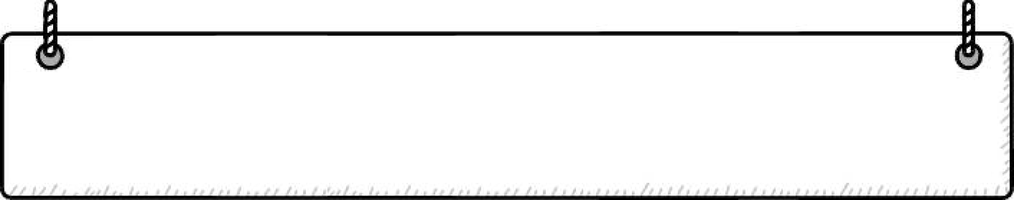
得 分

Unit 2 What Are You Doing?
Dino on the Go (4)

Class: _______ Number: _______ Name: ______________(中+英2%)
一、Look and Write 寫出正確的單字（每題8分，共48分）
swim / eat / drink / write / run / sleep
1. | 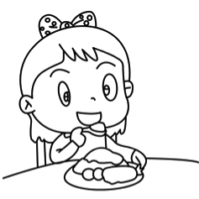 | 2. | 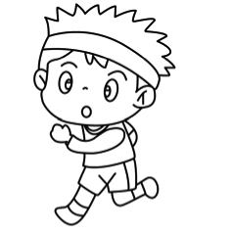 | 3. | 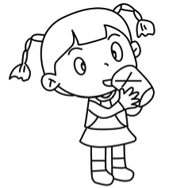
 | 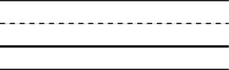
4. | 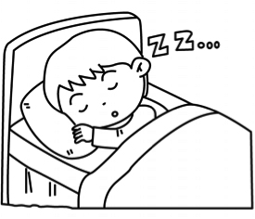 | 5. | 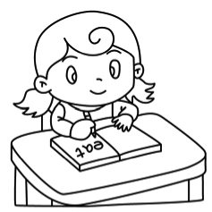 | 6. | 
二、Read and Choose讀一讀，選出正確的答案 （每題5分，共30分）
（ ）1. He ______ cooking. (A) is (B) are (C) am
（ ）2. _____ he doing? (A) What (B) What’s (C) Is
（ ）3. Time ______ lunch! (A) for (B) to (C) on
（ ）4. A: What’s she doing? B: She’s ________. (A) run (B) runing (C) running
（ ）5. A: What’s he doing? B: ____ eating. (A) I’m (B) He’s (C) She’s
（ ）6. A: What _____ you doing? B: I’m cooking. (A) are (B) is (C) am
四、Look and Answer 依據圖片，回答句子（每題10分，共20分）
1.   | read | What are they doing?
 | read | 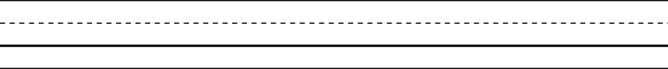
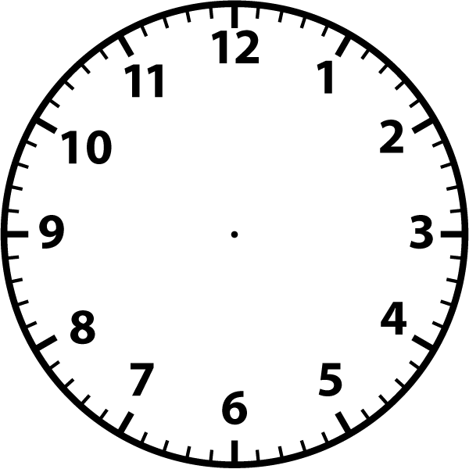
2.
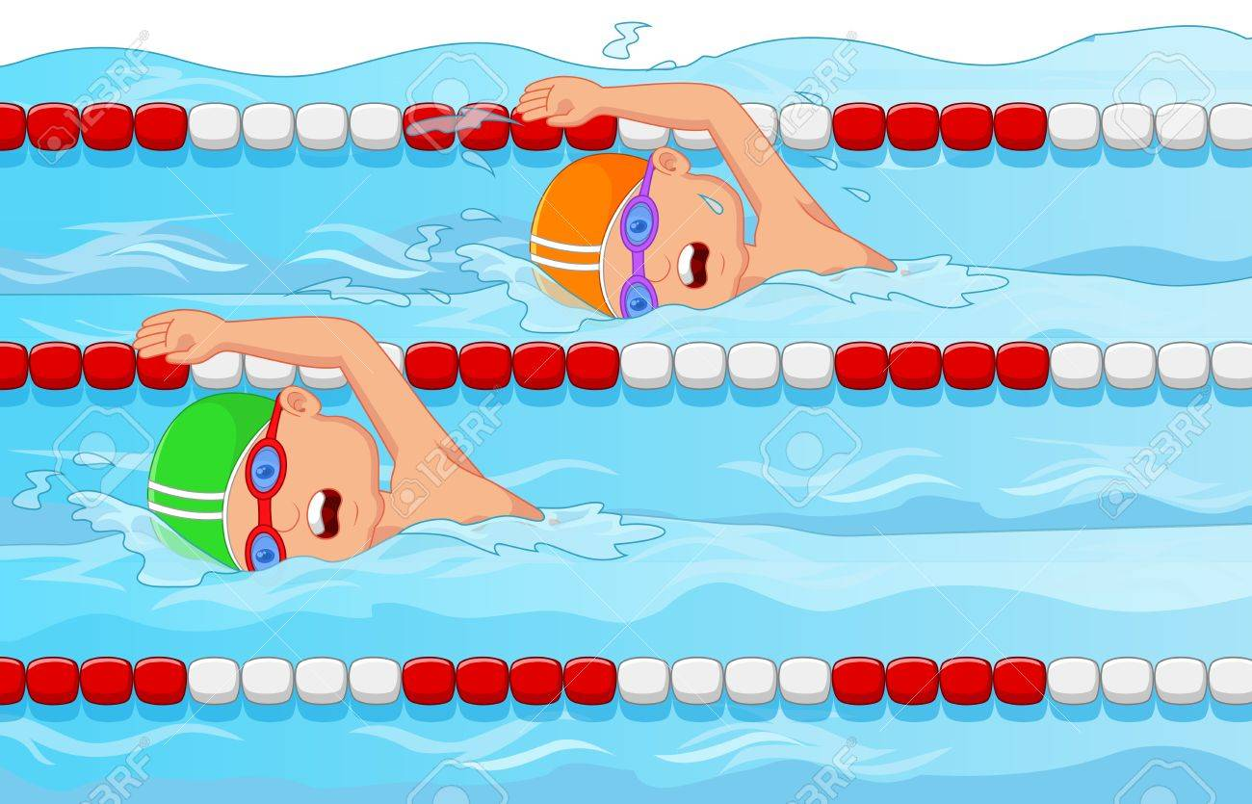
It’s twelve twenty. We are __________.
畫出正確的時間，並依提示寫出完整的句子。
swim

