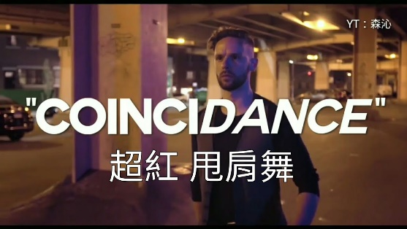**CoinciDANCE**

〈Handsome Dancer〉

The first man name was Kiki

He wear such little pants

His brother was a ________

But Kiki loves to dance

The second man was Choo Choo

A master of ________

He loved **damsels in distress** but not as much as dance

And then one day had happened

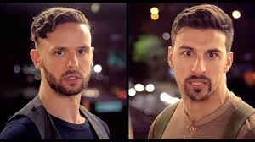

They went out _____the world



They went on to a journey

**Idolize** by the _____ and _____

They learn so many **lessons**

In all of the foreign lands

But no matter _____ they wound up

They never stopped to dance

On day inside station

In **Amsterdam** **perchance**

The men were dancing _________ by the man with the **crooked glance**

They turned to face each other

It was just happened **stance**

That these two men would meet that day and do that **faithful** dance

"WOW, you can really ______"

"WOW, you can really ______"

He went (Dum-Dum-Dum) He went (Dum-Dum-Dum)

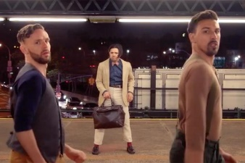They said: We’ve both been ________ all this time

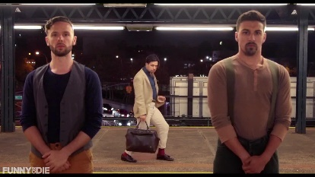Oh what a coinciDANCE!

And then they danced together

Like no one’s danced before

The **diplomats** were dancing

They cancelled the orders of ______ (no more)

The whole world **celebrated**

With no more **violence**

And all because these men crossed path

What a __________!

Let's dance!